**1. WAP to create a simple XML document to display the address book.**

**Output:**

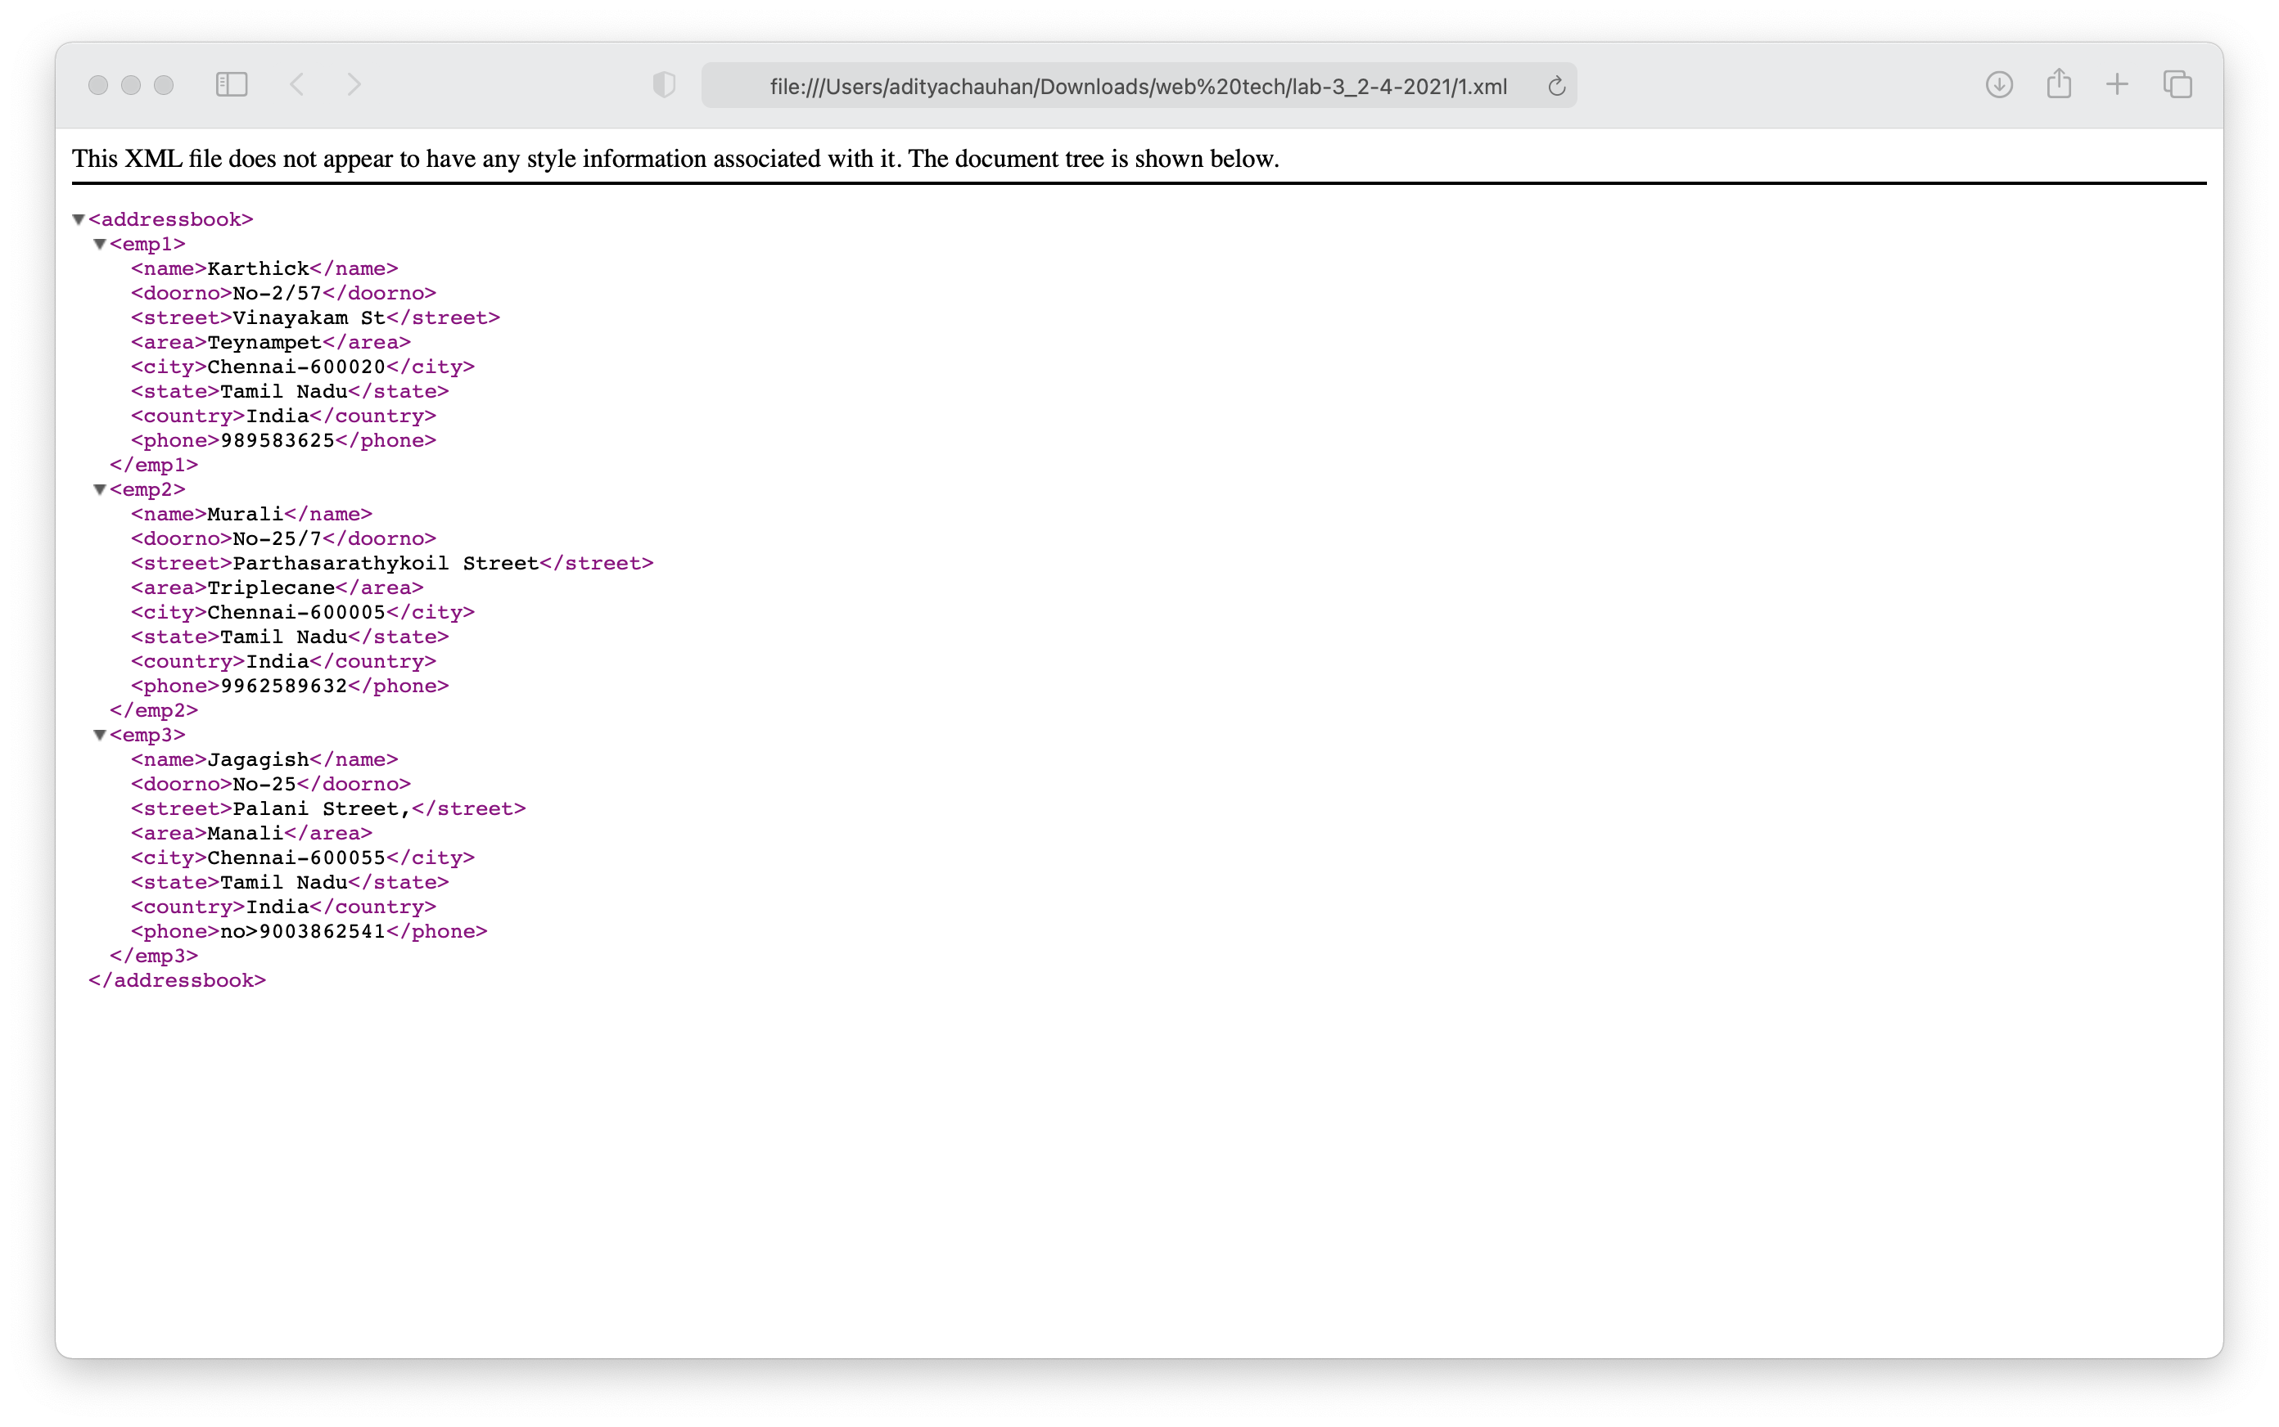

**2. WAP to design an XML document to store information about a student in an**

**engineering college affiliated to XYZ. The information must include USN,**

**Name, and Name of the College, Branch, Year of Joining, and email id.**

**Make up sample data for 3 students. Create a CSS style sheet and use it to**

**display the document.**

**Output:**

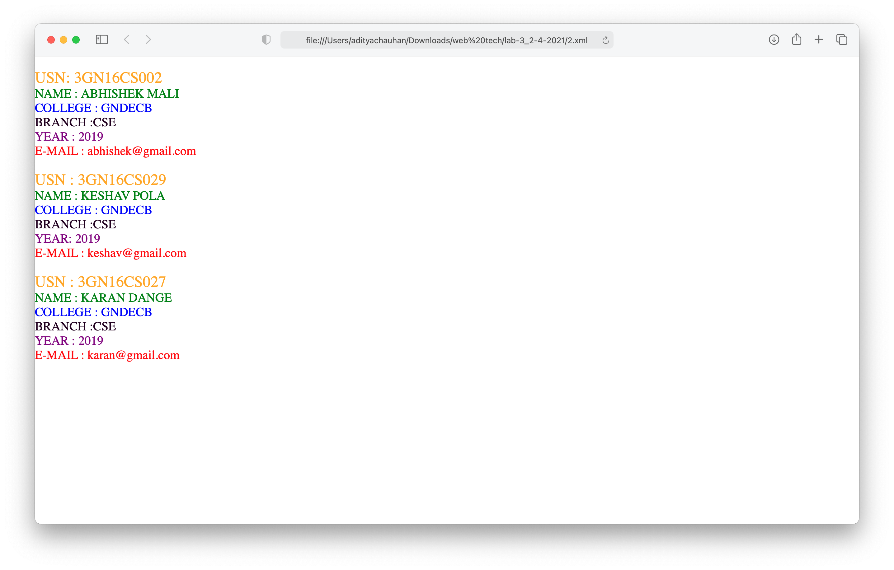

**3. WAP to create a simple XML document to display the breakfast menu.**

**Output:**

